Project Development Phase Model Performance Test

Date | September 2026
Team ID | 6ab8b3c5c23107aaaa72d06e
Project Name | Project - Streamlining IT Procurement: Automating Standard Laptop Orders with Flow  Designer
Maximum Marks | 10 Marks

Model Performance Testing:
Project team shall fill the following information in model performance testing template.

S.No. | Parameter | Values | Screenshot
1. | Metrics | Regression Model:  MAE - , MSE - , RMSE - , R2 score -  Classification Model:Confusion Matrix - , Accuray Score- &  Classification Report - | 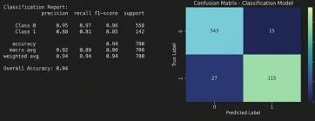
2. | Tune the Model | Hyperparameter Tuning - GridSearchCV applied for Random Forest  Validation Method - K-Fold Cross-  Validation (k=5) | 